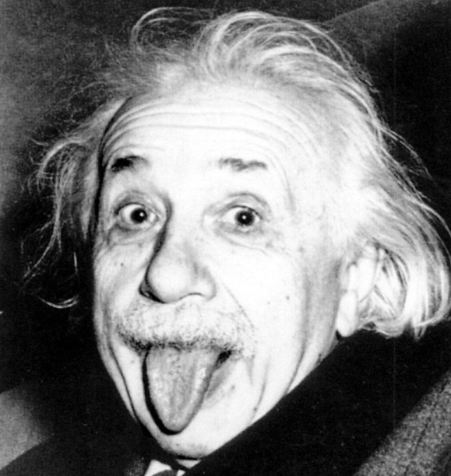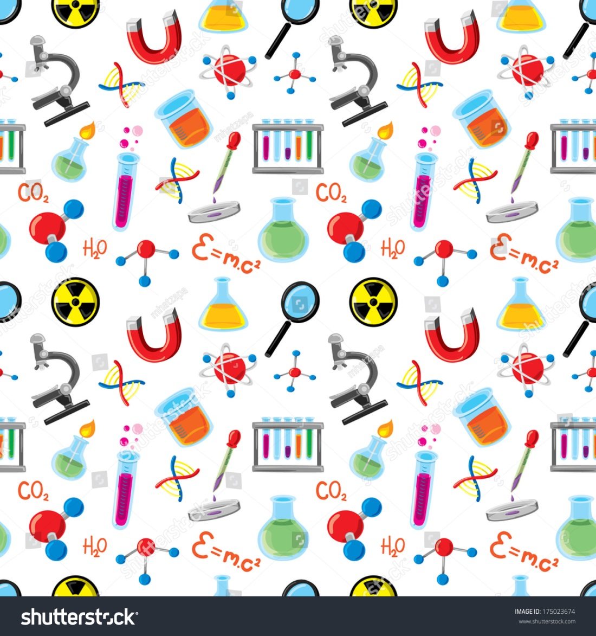

This Week:

Science: Cont. Electricity & Magnetism

Social Studies: Begin “Gilded Age-1900s” unit

ELA: MLA Review & Rhetoric Unit

Math A: Chapter 3 Equations in Two Variables Test Friday (11/6)

Math B: continue Ch3 Equations in Two Variables

Literature: Continue Catching Fire

TO DO:

The most beautiful thing we can experience is the mysterious. It is the source of all true art and science.  
- Albert Einstein

Dates to Remember:

11/11: No school: veterens day

11/25-11/27: Thanksgiving Break

Miss Southard’s Newsletter

11/9-11/13

Miss Southard’s Newsletter

12/2-12/6