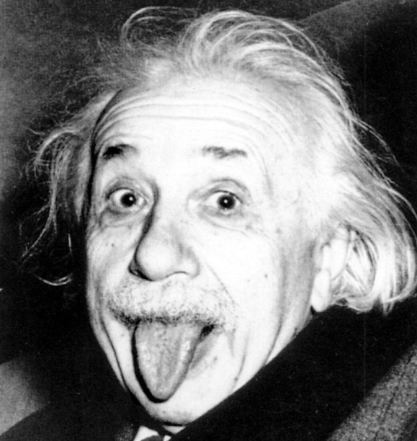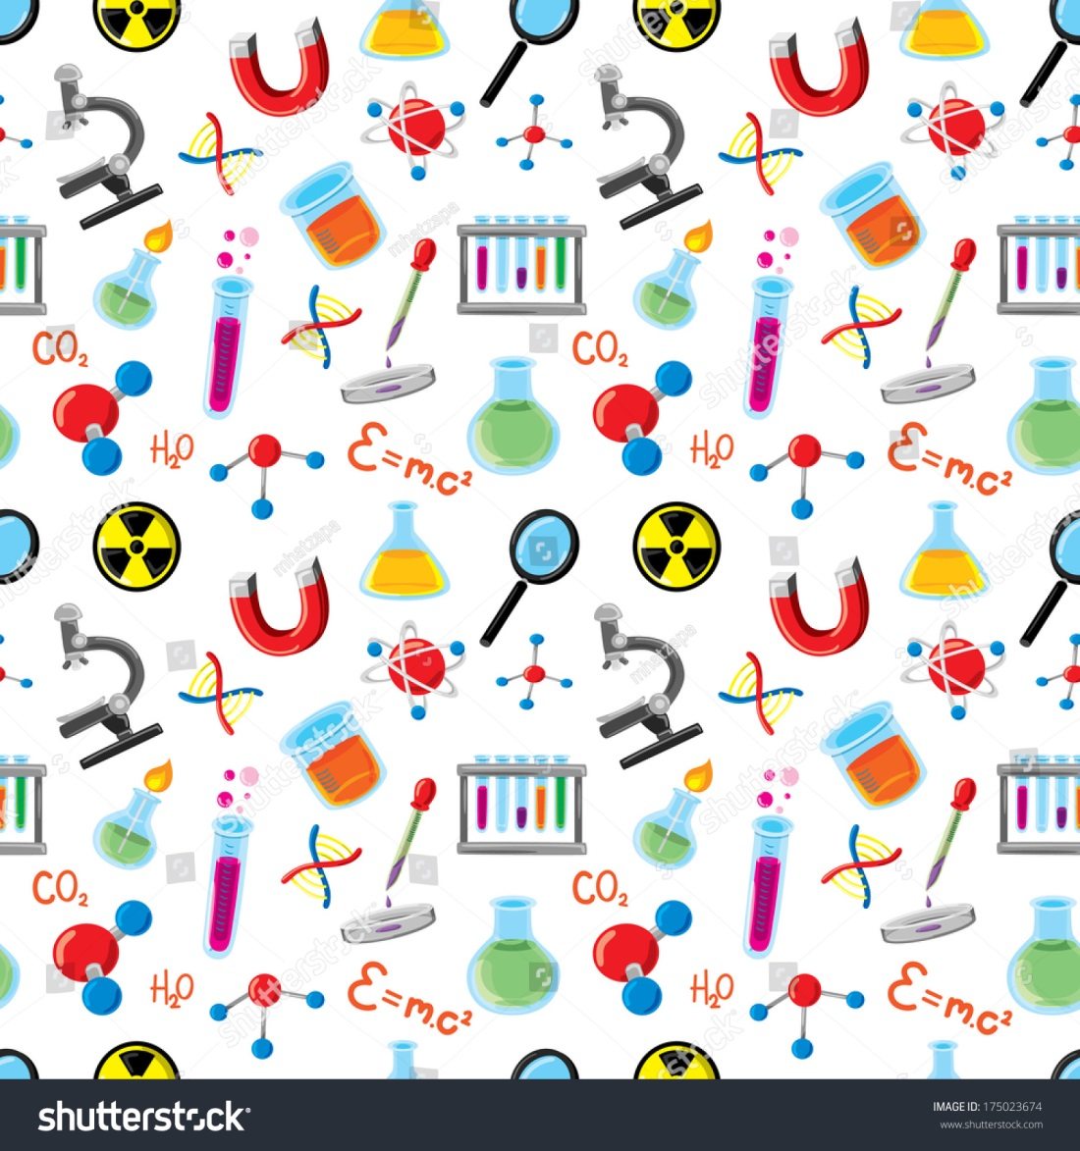

1/20: MLK Jr. day- no school

2/14: no school

2/17: Presidents day – no school

2/28: half day

Science: Continue motion Chapter

Social Studies:  Continue The Roaring 20s unit

Vocabulary Mini-Assessment Wednesday, 1/20

ELA: Verb Moods Test on Friday 1/24

Math A:  Start Chapter 7 - Congruence and Similarity

Math b: continue Ch7 Congruence and Similarity

Literature: Continue catching fire

Health: continue Nutrition Chapter

Spelling: lesson 15 words

The most beautiful thing we can experience is the mysterious. It is the source of all true art and science.  
- Albert Einstein

This Week:

Dates to Remember:

Miss Southard’s Newsletter

1/21 – 1/24