Classroom Rules:
- Cooperate with your teacher and classmates.
- Respect the rights & property of others.
- Carry out your student responsibilities.
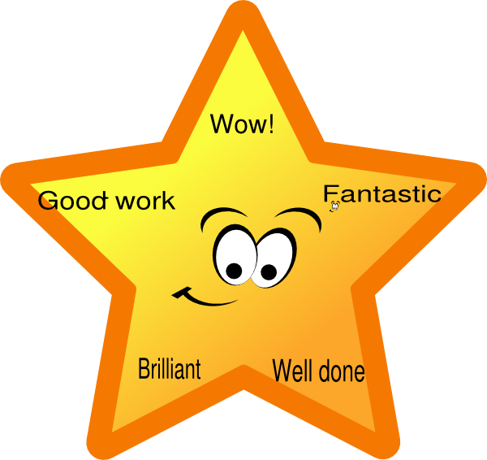
Rewards:

Each student will receive a punch card. Once a punch card is full, the student can pick a reward from the prize jar.

Discipline Plan:
- Verbal warning
- Loss of lunch recess and/or PE class
- When a student has lost four lunch recesses or PE classes due to minor behavior problems, the student will receive one detention. The parents and principal will be notified.
- Students will receive one detention for a severe behavior infraction.

*See the Middle School Handbook for more details regarding the Discipline Plan.

Extra Credit:
Extra credit assignments will be given out throughout each quarter. It is in each student’s best interest to take advantage of every extra credit opportunity!

Weighted Grades:
Tests 40%
Quizzes & In Class Assignments 30%
Homework 25%
Participation 5%

It is the student’s responsibility to ask questions and seek out extra help before/after school or during academic prep. I am here to help each student learn and work up to their potential!

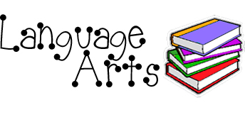
Mrs. Kunz
Grade 7

Students will take notes in class and complete practice problems. Each day a new topic will be discussed. Homework problems will be given to review the concept discussed in class. Worksheets and quizzes will be given in class to ensure comprehension of the topics. A unit test will be given at the end of each chapter.
Topics to be Covered:
- Subjects, Predicates, & Sentences
- Nouns
- Verbs
- Pronouns
- Adjectives & Adverbs
- Clauses & Complex Sentences

Homework: Students will receive participation points for completing homework assignments. Three points will be given for completing the entire assignment, two points for partial, and one point for less than half. Additional homework assignments may be sent home that will not be counted as participation.
After checking the homework in class, students will complete a homework check. The homework check will be completed without the book and will contain ten problems from the previous night’s homework. This will be taken as an in class grade.

After the class completes a grammar unit, a writing assignment will be started.
Students will write three papers throughout the year as well as various mini writing assignments. All students will follow a writing process: Prewriting, Draft One, Peer Review, Draft Two, Teacher Conference, Final Paper. Deadlines will be set by the teacher and will vary based on each student’s progress.
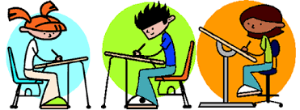
Papers:
- Argument
- Informative
- Narrative

Analogy Journal:
After a mini lesson covering analogies, students will complete analogies in their journals on Wednesdays and Fridays. The analogies will be posted on the smartboard for the students to reference. Answers will be written in their journal; the format will be discussed in class. If a student is absent, a print off of the analogies will be sent home. If for some reason the copy is not sent home, it is the student’s responsibility to ask the teacher for the copy. Analogy journals will be collected at least once a quarter and taken as an in class/quiz grade. The journals will be graded on a curve. Two-three days notice will be given for collection of journals so students will have time to make sure they are in order.

Monthly Writing Assignments
Students will be required to complete two paragraphs each month. This is an independent writing assignment that will be modeled once for the class. Students will need to follow the format given and use their free time in class to complete the assignment. The paragraphs will be collected each month and taken as a participation grade.

Extra Credit
Students will be offered extra credit on Tuesdays and Thursdays. Students will have an opportunity to complete a half sheet containing four problems. Each problem is worth half a point. If a student doesn’t put their name on the paper, it will be thrown away and no points will be given. Points will be added to the English-Language Arts grade at midterm and the end of the quarter.

Hello!
My name is Colleen Kunz. This is my second year working at Bartelso Elementary, and my eleventh year teaching. I graduated from Eastern Illinois University in 2008 with a Bachelor of Science in Elementary Education. In 2010, I attended McKendree University to receive my middle school endorsement., I have experience teaching first, second, third, fifth, sixth, seventh, and eighth grade.
I got married in 2016 to my husband, Keith. We immediately adopted a dog, Louie. In May 2017, we had our first child, Kane William. He has brought us so much joy, and we love watching him learn and grow each day. In my freetime I enjoy boating, shopping, and spending time with family and friends.
I am looking forward to teaching your children. I thoroughly enjoyed teaching here last year, and I am excited to start a new year! If you have any questions, please feel free to contact me at anytime. It is important that we work together to help your child grow their love for learning.

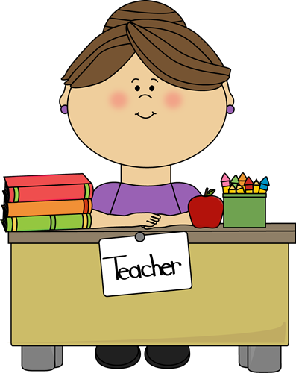
These are a few of my favorite things…
Food: Pizza, Cookies, & Salads
Restaurants: Qdoba, Mungos,, & Starbucks
Drink: Diet COke & Coffee
Color: Yellow
Shops: Target, Gap, & Loft
Vacation: Boating on Bull Shoals Lake or the Ozarks
Music: Classic Rock
Book: The OUtsiders

Literature Mrs. Kunz Grade 7
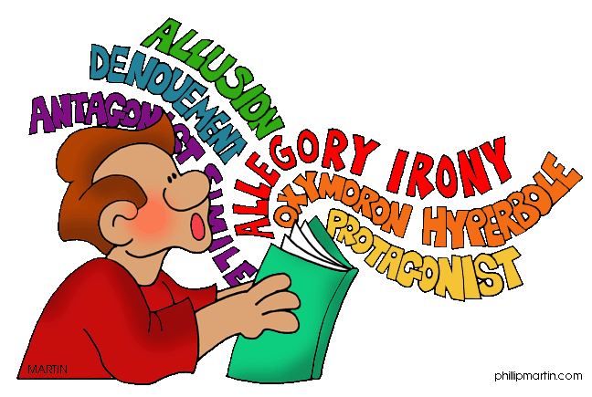
Topics to Be Covered:
- Literary Elements
- Drama
- Plays
- Nonfiction
- Scope Magazine
- Poetry
- Figurative Language & Imagery
- Seasonal

Novel Units:
Tuck Everlasting
A Christmas Carol
The Outsiders
Across Five Aprils

Monthly Reading:
Students will be required to read one book a month from a particular genre. At the end of the month a book report will be due. Students can choose from a variety of book reports. More information will be sent home at a later date.

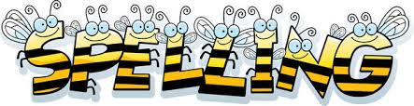
Spelling/Vocabulary words will be given every week. It is important that students understand the meaning of a word as well as know how to spell it. Tests will be at the end of every week. Students will be tested on correct spelling as well as use of the word.
*When a novel is being studied the spelling words will correlate.

Health

Topics to be COvered:
- Mental & Emotional Health
- Family & Social Health
- Nutrition
- Personal Health & Physical Activity
- Violence & Injury Prevention
- Consumer & Community Health

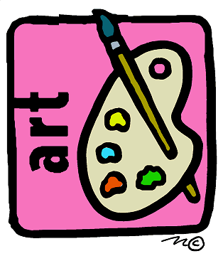
Students will complete weekly art projects. At times, students may need to bring in an item from home; plenty of notice will be given if this is necessary.

