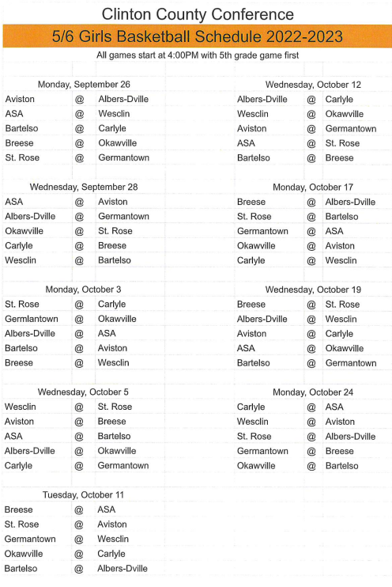

**Germantown 6th Grade Tournament  
September 19th-23rd**

**ASA 6th Grade Tournament  
October 7th and 8th**