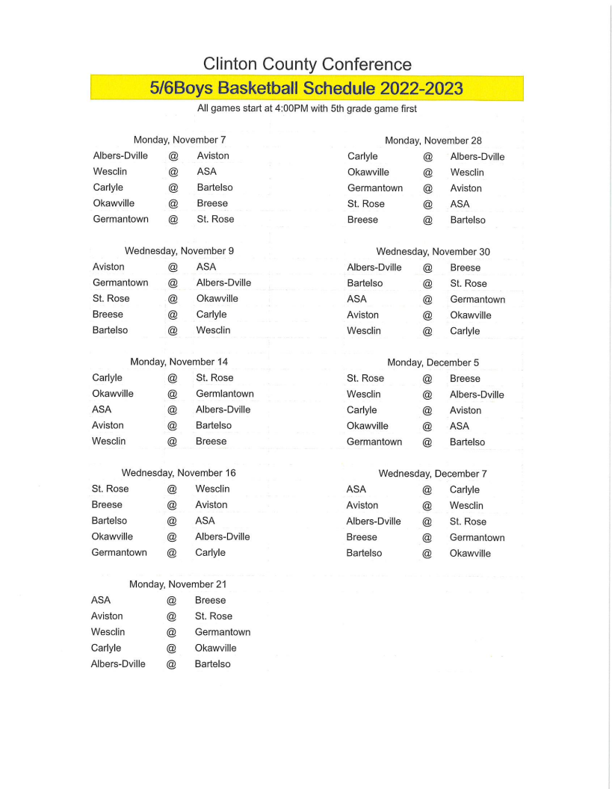

**Aviston 6th Grade Tournament  
November 4th and 5th**

**All Saints 6th Grade Tournament  
January 6th and 7th**