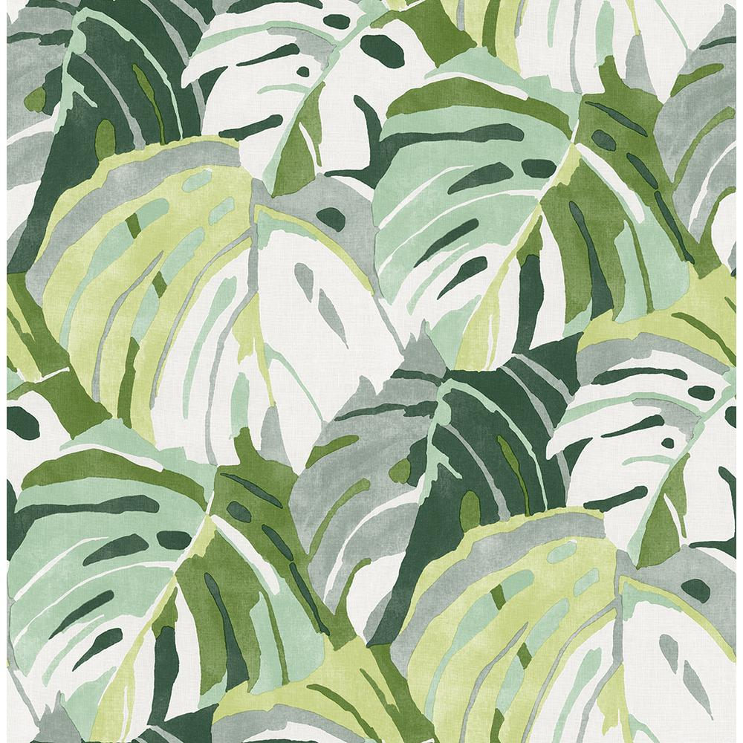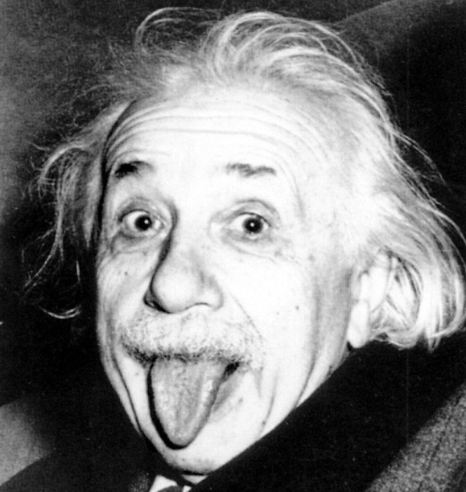

This Week:

Science: cont. Chemical bonds and equations chapter

Social Studies: Begin Great Depression study

ELA: Demonstration Speeches

Math A: Finish Chapter 8 Volume and Surface Area.  Test Wednesday, 3/30.

Math B: Continue Chapter 8 Volume and Surface Area

Literature:  Author's Purpose & Text Structure; Root Words Spelling & Vocab Quiz Friday, 3-25

To do list:

The most beautiful thing we can experience is the mysterious. It is the source of all true art and science.  
- Albert Einstein

Dates to Remember:

3/18: Irelyns birthday

4/13: early dismissal 1:30

4/14-4/18: Spring Break

Miss Southard’s Newsletter

3/22 - 3/25